Jenkins ppt,

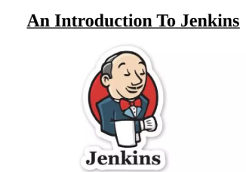

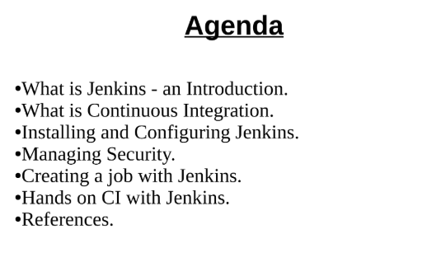

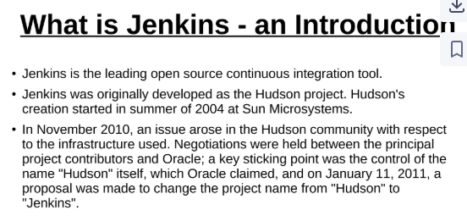

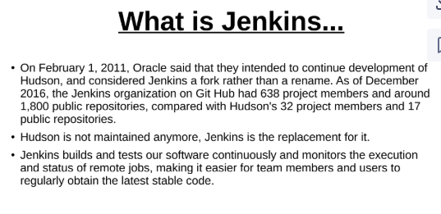

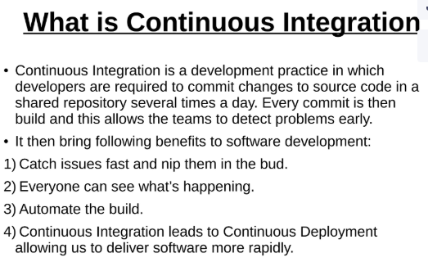

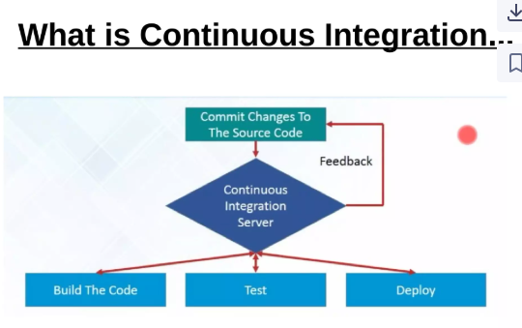

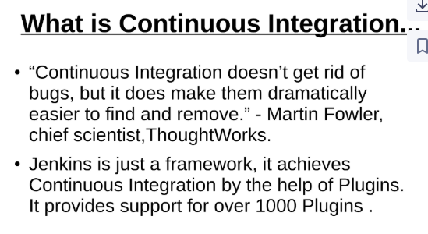

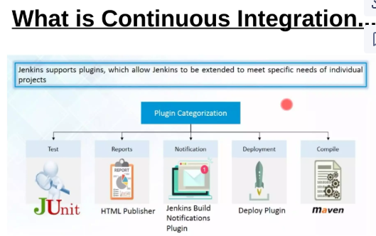

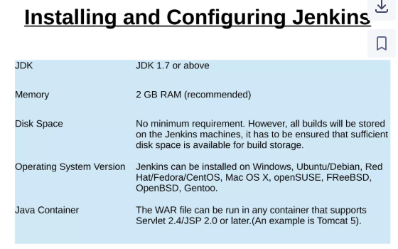

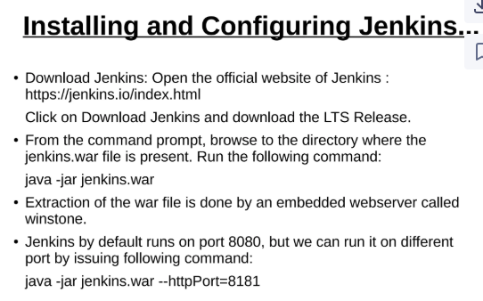

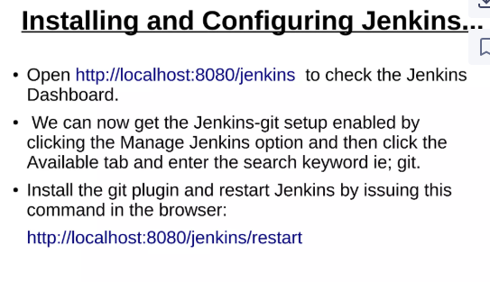

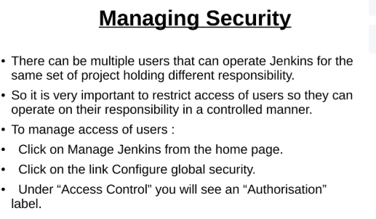

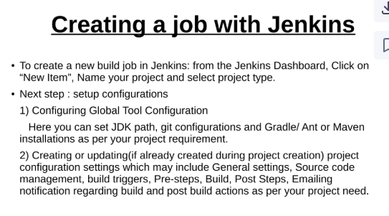

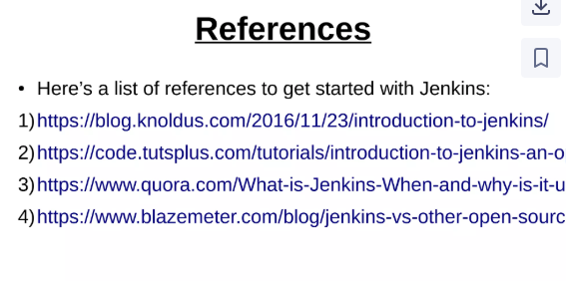

Slide 3: What is Jenkins?
- Jenkins is an open-source automation server.
- It helps to automate the building, testing, and deployment of applications.
- Written in Java and supports many plugins.
- Core tool for implementing CI/CD.

Slide 4: Why CI/CD?
- Continuous Integration: Developers integrate code into a shared repo frequently.
- Continuous Delivery: Automated release of code to production.
- Benefits:
  - Early bug detection
  - Faster development
  - More reliable releases

Slide 5: Jenkins Architecture
- Master:
  - Manages tasks, job scheduling, and monitoring.
- Agents (Slaves):
  - Run build jobs assigned by master.
- Agents can run on different OS or machines.

Slide 6: Jenkins Features
- Easy installation and setup
- 1800+ plugins (Git, Docker, Maven, Ansible, etc.)
- Distributed builds via agents
- Extensible via Jenkinsfile (pipeline as code)
- Integration with major tools

Slide 7: Jenkins Plugins
- Git plugin (pull code from GitHub/GitLab)
- Docker plugin (build/push images)
- Pipeline plugin (create scripted pipelines)
- SonarQube plugin (code quality checks)
- Credentials plugin (secure API keys/secrets)

Slide 8: Jenkins Pipeline (Jenkinsfile)
- Pipeline = CI/CD workflow defined as code
- Example:
pipeline {
agent any
stages {
stage('Clone') {
steps {
git url: 'https://github.com/your/repo.git'
}
}
stage('Build') {
steps {
sh 'npm install'
}
}
stage('Deploy') {
steps {
sh 'docker build -t app .'
sh 'docker push app'
}
}
}
}

Slide 9: Installing Jenkins
- Install Java (JDK 11+)
- Download Jenkins WAR: wget http://pkg.jenkins.io/jenkins.war
- Run Jenkins: java -jar jenkins.war
- Access via browser: http://localhost:8080
- Install recommended plugins

Slide 10: Jenkins Use Case
- Code hosted on GitHub
- Jenkins pulls code → runs tests → builds Docker image
- Pushes Docker image to Amazon ECR
- Updates ECS service using AWS CLI

Slide 11: Jenkins vs Other CI/CD Tools
Tool | Jenkins | GitHub Actions | GitLab CI | CircleCI
Open Source | Yes | Partially | Yes | No
Plugin Ecosystem | Huge | Limited | Moderate | Moderate
Self-hosted | Yes | No | Yes | No

Slide 12: Benefits of Using Jenkins
- Free and Open Source
- Huge community support
- Customizable pipelines
- Works across platforms and languages
- Supports cloud-native deployments (ECS, EKS, Kubernetes)

